Northgate Bar Project
Jimmy Barnett, Kayla Davis, Zach Johnson

Our project is a northgate map detailing bar specials, hours and age requirements. It will contain interactive popups, routes through the bars in the most efficient manner, and the ability to specify your age to show you the best bars. The goal was to create something similar to aggiemaps or google maps, but with less, more straightforward features. The number of icons and features on aggiemaps can be confusing and hard to read, something used for northgate would need to be straightforward and with few features.
Expected Functions:
-working age buttons to hide/show bars you cannot/can go to due to age
-Bar-hopping route through northgate to hit every bar most efficiently
-interactive popups on each bar:
1. age
2. hours
3. specials/days
4. bar name

Current Functions:
-working JS ArcGIS basemap with toolbar,
-button functionality not yet implemented
-framework for featurelayer importing & interactive popups already in place, waiting on completion of featurelayer (Jimmy Barnett)
-(It will be prettier I promise)
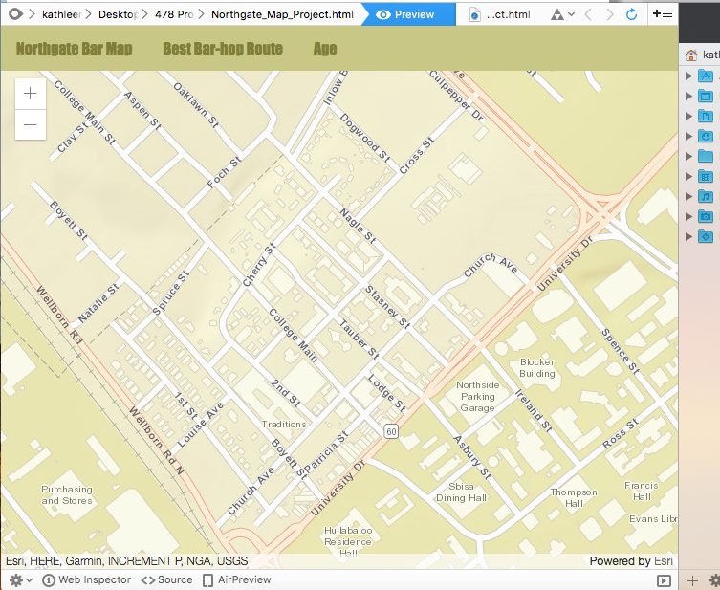

-Sheet files with (most) data we will need (Kayla & Zach)
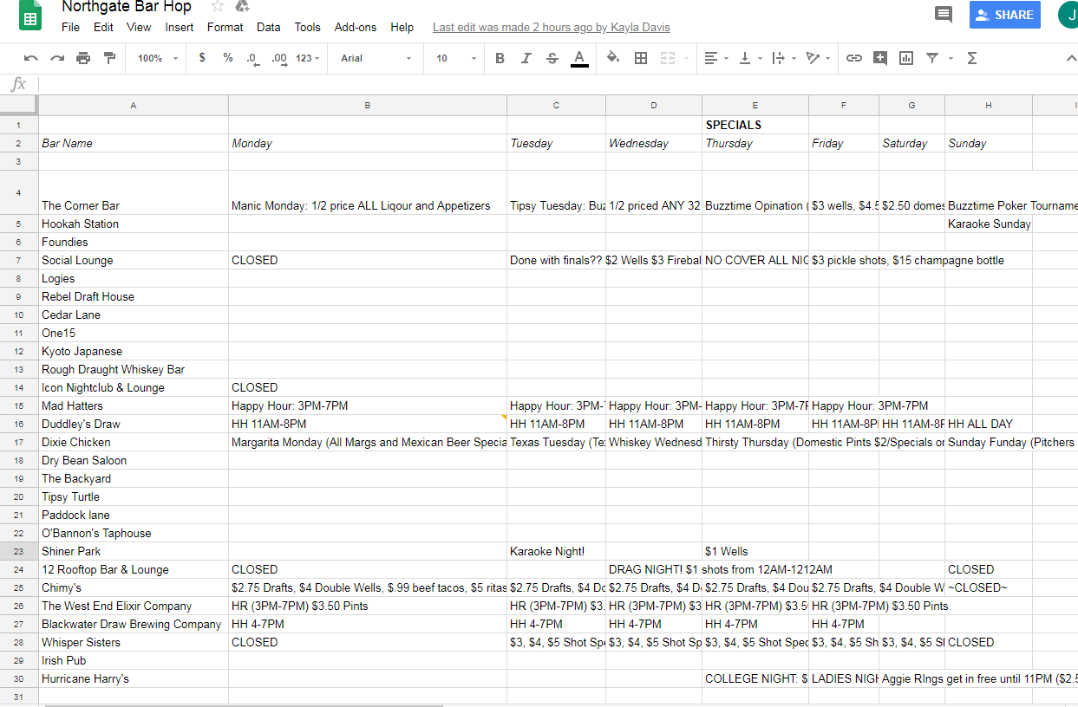

-(in progress) arcmap feature layer containing bar data to be imported into JS code (Jimmy)
